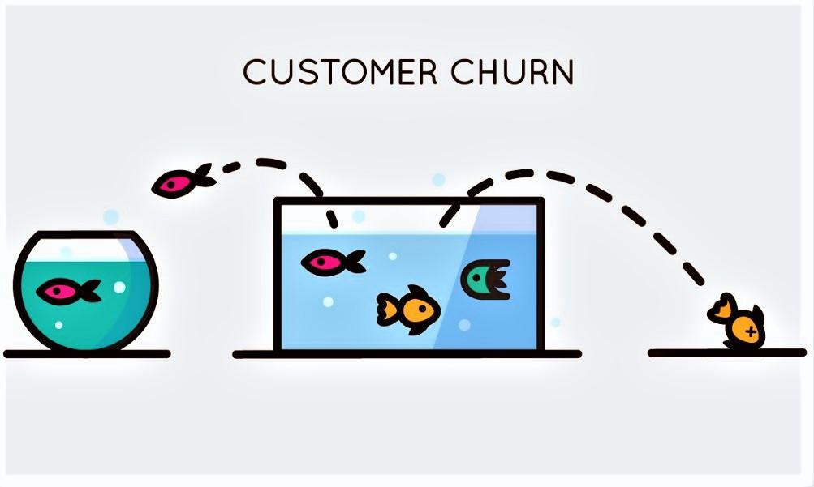

**CHURN BI PROJECT PROPOSAL**

**BUSINESS ANALYSIS PROJECT**

**Group 3:**

Chasnick DESIR

[chasnickdesir@gmail.com](mailto:chasnickdesir@gmail.com)

Fritz Gerald Junior VALCIN

[fritzgeraldjuniorvalcin@gmail.com](mailto:fritzgeraldjuniorvalcin@gmail.com)

Ketenie Flore THENEUS

[ketteniefloreheneus@gmail.com](mailto:ketteniefloreheneus@gmail.com)

**Plan**

**I-Introduction**

**II-Defined context**

**A-Context**

**B-Problematic**

**C-problem Background**

**III-Stakeholders**

**IV-Measure of performance**

**A-How do the client, organization and other stakeholders measure the Business Problem?**

**B-Importance of the problem**

**V-Methodology**

**VI- Result**

**Deliverable Part I**

**Deliverable Part II**

**VII- Discussion and Proposed Solutions**

**-Deliverable Part I**

**SWOT ANALYSIS**

**Main Solution**

**Proposed Solution(SWOT For each)**

**Challenge you might encounter.**

**How to face them?**

**-Deliverable Part II**

**SWOT ANALYSIS**

**Main Solution**

**Proposed Solution(SWOT For each)**

**Challenge you might encounter.**

**How to face them?**

**VIII- References**

**AYITI ANALYTICS BOOTCAMP 2021**

**I-Introduction**

Every business in the world sometimes needs BI analysis to face their threats. On this project our team will help Telcom, a leading telecom company to find a way to fight against their threat and fix their problem. problem who must defined by: “Market Part losses’

**II-Defined context**

**A-Context**

Our analysis concerns a telecommunication company which, despite its leading position in the market, is facing a big problem: "Competitors are stealing customers regularly". This company offers communication services, internet access, online security etc... and no longer has a great opportunity for growth. Following the loss of customers, the company seeks to measure the churn rate in order to:

1- Find out the common characteristics of customers who cancel their contracts.

2-Predict which category of customer is most likely to cancel their contracts in the future.

3-Know what could be done to encourage customers who are likely to cancel their contracts to remain loyal to the company.

**B-Problematic**

As we said earlier, the leading telecom company TELCOM has one big problem: “rivals trying constantly to steal their customers”.

The Telcom Problem is that: “ For several months, they lose a lot of customers”. They don’t know what they can do to fix this situation.

**C-Problem Background**

**Who identified that there was a problem/ Have there been any other attempts to solve this problem?**

The problem was identified by the Telcom administration board and they chose us to help them to find a way to solve it.

They faced this threat several months ago and they cannot wait.

**III-Stakeholders**

Stakeholders involved in the problem

* In the company, the marketing and customer service departments that have a strong interest in finding a solution to the problem they face.
* Marketing department: This department would like to know which of its customers are most likely to cancel their contracts and propose service plans that are most likely to interest them.
* The customer service department which wants to be proactive with customers who are about to cancel their contracts and encourage them to stay with TELCOM.
* Shareholders are also concerned about the financial losses caused by customers leaving.
* Customers, discouraged from staying with TELCOM.

**Relation between the stakeholders.**

Since the objective of any company is to maximize its utility, i.e. its profit, the shareholders can then put pressure on the management team to correct the situation.

The management team will then ask the marketing and sales departments to each take care of a specific aspect of the problem to keep customers.

Our job is to satisfy these different interests in a reasonable time frame.

**IV-Measure of performance**

A-How do the client, organization and other stakeholders measure the Business Problem?

Telcom measures the business problem by a loss rate report in their total market client and also by the financial impact on their revenues.

**B-Importance of the problem**

This problem is really important for the company because in the long run a company that loses customers can find itself bereft of its source of income and go bankrupt.

**V-Methodology**

In order to carry out the project and to find solutions that could rectify the situation, we will conduct a study in two stages.

In the first step we will:

- use churn data, a dataset of approximately 7,000 customers containing demographic information as well as information about the services used by each of these customers.

-Perform a descriptive statistical analysis of the database using Python ressources

- Our analysis will allow us to answer those questions:

**1.-** How much is churn affecting the business? How big is churn compared to the existing customer base ?

**2.-** Explain churn by the below categories. Are there any factors that combine to be especially impactful ?

1. Customer demographics like age and gender
2. Services used
3. Billing information

**3.-** What services are typically purchased by customers who churned ?

Are any services especially helpful in retaining customers?

**4.-** How long will it take for the company to lose all its customers ? Which demographics will they lose first ?

-We will use our descriptive analysis to build a dashboard with significant insight.

On the second step , we will use use different machine learning algorithm in Python like Logistic regression, Random Forest Method, Gradient Boosting Method to create analyses susceptible to answer those questions:

**1.-** Are there types of people who churn at higher rates? We will come up with 2-3 profiles to give executives an idea of who churns often. Try to look

several factors deep for example: people with no internet service and no phone service, or women who are senior citizens

**2**.- Do you have any recommendations on how to reach groups of people who churn at high rates ?

**3.-** We will create a case study for one of our customer profiles. Show how much additional revenue Telcom could make by increasing sales by 10% in that profile.

**4.-** We will use a clustering algorithm like K-Means to break customers into groups.

1. How many groups did we build and how did we decide on that number of groups ?
2. How does churn vary by group ?
3. How is this similar or different to our analysis without using Machine Learning ?

**VI- Result**

**Deliverable Part I**

gender ratio

Male 3555 50.47565

Female 3488 49.52435

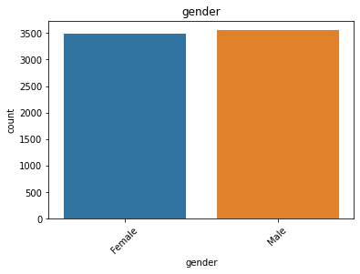

This graph shows that the client repartition is 50% male and 50% female.

SeniorCitizen Ratio

0 5901 83.785319

1 1142 16.214681

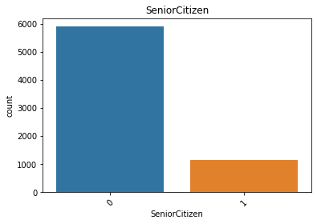

This graph shows that 84% of the customers are non SeniorCitizen and 16% are SeniorCitizen.

Partner Ratio

No 3641 51.69672

Yes 3402 48.30328

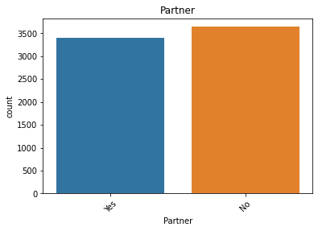

This graph shows that 52% of customers have no partners and 48% have partners.

Dependents Ratio

No 4933 70.041176

Yes 2110 29.958824

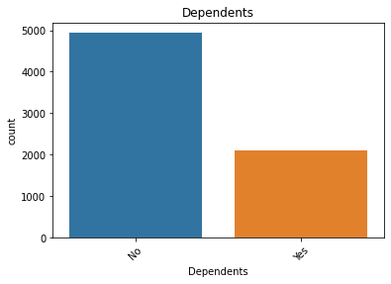

This graph represents the 70% of the customers who are not dependents and about 30% of them are.

Contract Ratio

Month-to-month 3875 55.019168

Two year 1695 24.066449

One year 1473 20.914383

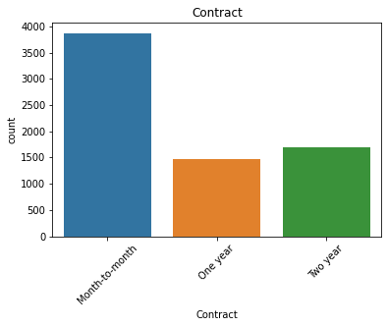

This graph shows that the ratio of customers with month to month contracts are 55, those with two year contracts are 24 and 21 for those with one year contract.

PaymentMethod Ratio

Electronic check 2365 33.579441

Mailed check 1612 22.887974

Bank transfer (automatic) 1544 21.922476

Credit card (automatic) 1522 21.610109

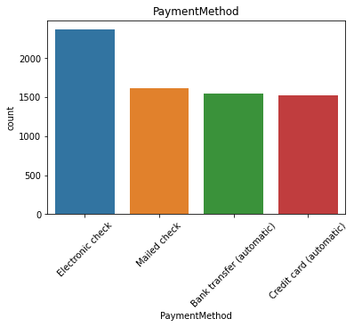

This graph shows the ratio of the customers who have an Electronic check payment method amount to 33.579441, those who have a Mailed check payment method amount to 22.887974, 21.922476

for those who have bank transfer (automatic) and those who have credit card payment method (automatic) are

1522 21.610109.

Churn Ratio

0 5174 73.463013

1 1869 26.536987

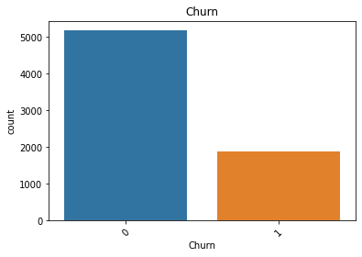

When we look at this graph we can see that the ratio of customers who have not churn is 73.463013 % and those who have churn is 26.536987 %.

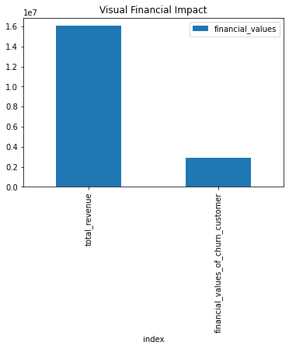

This graph helps us to visualize the financial Churn impact. Telco loses approximately $2,862,926 per month on a total of $16,056,168. That is a ration of 17.8% of its income.

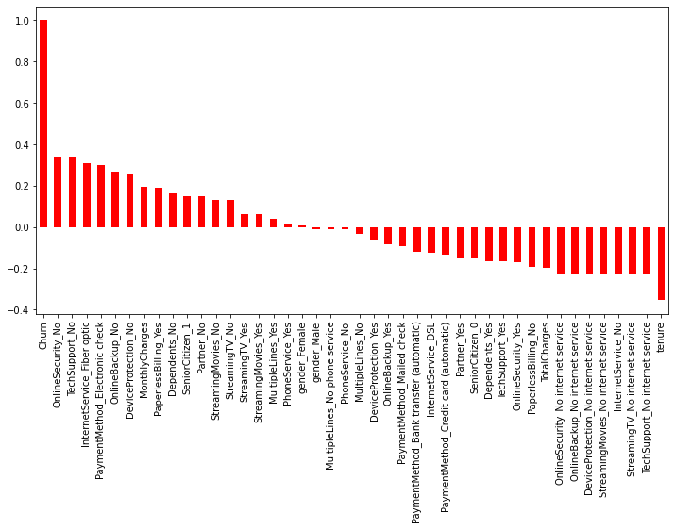

We see here that no single variable explains more than 40% of the reason for contract termination. We can assume that it is a combination of several variables that pushes customers to abandon Telco.

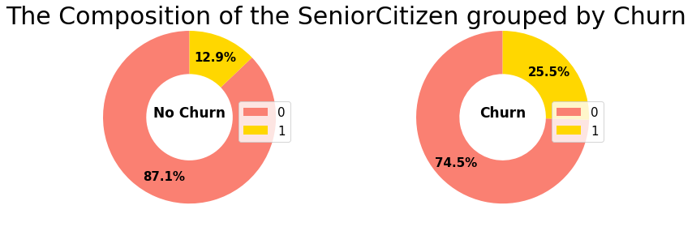

This graph shows that among the No Churn 12.9% are Senior Citizen and 87.1% are not Senior Citizen.

And among the Churn 25.5% are Senior Citizen and 74%5 are not Senior Citizen.

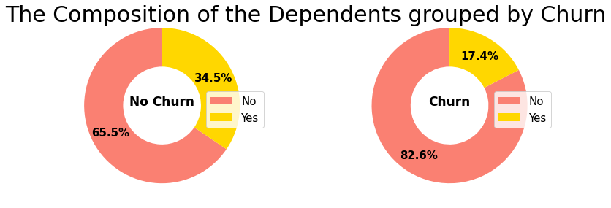

This graph shows us that among the No Churn 34.5% have Dependents and 65.5% have no Dependents.

And among the Churn 17.4% have Dependents and 82.6% have no Dependents.

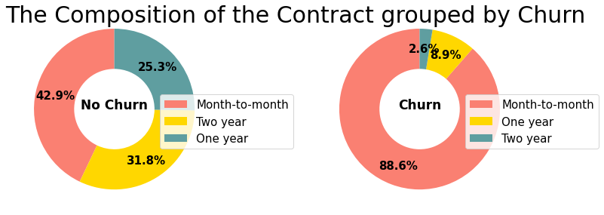

This graph shows that among the No Churn 25.3% sign a One year contract, 42.9% sign a Month-to-month contract and 31.8% sign a Two year contract.

And among the Churn 2.6% sign a Two year contract, 88.6% sign a Month-to-month contract and 8.9% sign a One year contract.

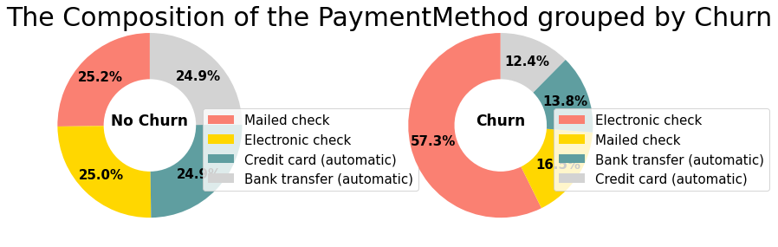

This graph shows us that among the No Churn 24.9% have a payment method by Bank transfer, 24.9% have a payment method by Credit card(automatic), 25.0% have a payment method by Electronic check and 25.2% have a payment method by Mailed check

Among the Churn, 12.4% have a payment method by Credit card(automatic), 13.8% have a payment method by Bank transfer(automatic), 16.5% have a payment method by Mailed check and 57.3% have a payment method by Electronic check.

NB: If you want to understand more deeply our calculations, please visit our ipynb file here: <https://colab.research.google.com/drive/1cRyND5Gg1pxJlRWI9E9easyY_L7b5g5B#scrollTo=MnroPb-bdGJL>

**VII- Discussion and Proposed Solutions**

Aligning all that with the above analysis, we can draw some conclusion here for all 2 groups:

**THE LEAVING CUSTOMERS (Churn = Yes)**

26.6% of customers in this sample left within the last month. Most of them have no partners or dependents. They usually use fiber optic internet, and they don’t sign up for additional services other than Streaming movies/Streaming TV.

Most of them sign a Month-to-month contract, and leave as soon as the contract expires. Paperless billing and electronic payment are supported by them, and their bills are usually higher than other customers.

**Group's characteristics:**

**A-** Demographic info about customers:

26% are senior citizens 50% of men and 50% of women 64% have no partner 83% have no dependents

**B-** Services:

**-**70% use fiber optic internet, and only 6% of them do not sign up for the Internet.

**-**65-80% do not use additional internet services such as '**OnlineSecurity', 'OnlineBackup', 'DeviceProtection', and 'TechSupport'.**

**-**50% don’t use **Streaming movies/ Streaming** TV and 40% do.

**C-** Customer account information:

-89% of customers sign a Month-to-month contract. -75% adopt paperless billing.

**-**57% use electronic payment methods.

Most of them leave after only one month. Most of their monthly charges are distributed in areas with higher monthly charges, and 60% of their monthly charges are higher than average.

The maximum Total Charges is 8685 dollars, but 47% are concentrated in the range of 0-100 dollars.

**THE STAYING CUSTOMERS (Churn = No):**

-73.4% of customers in this sample stayed within the last month.

**Group's characteristics:**

**A-** Demographic info about customers:

* 13% are senior citizens.
* 51% of men and 50% of women.
* 53% have no partner.
* 66% have no dependents.

**B-** Services:

Most of them use **DSL internet**(38%).

The number of people selected by the three options is evenly distributed (**Fiber optic** 35%, No 27%).

36-40% do not use additional internet services, and the number of people using the additional services is similar to that of not using the services.

**C-** Customer account information:

-43% of customers sign a Month-to-month contract/ 32% sign a Two year contract/ 25% sign a One year contract.

-74%adopt paperless billing.

The proportion of users of the four payment methods is the same **(Electronic check/ Bank transfer (automatic)/ Credit card (automatic)/ Mailed check).**

The tenures concentrate around 1 and 72 months, and the number of customers is evenly distributed in other months.

Most of them don't spend much, the monthly charges are concentrated at 20 dollars. (Range: 18-120 dollars).

Most of their total charges are concentrated in areas with a small number. The higher the total charges, the fewer the number of people.

**Deliverable Part I**

**SWOT ANALYSIS**

SWOT Methodology

SWOT(strengths,, weakness, opportunities, and threats) analysis is a framework used to allow you to take stock of a company's relationship with its market. It's an approach that presents the company from a strategic perspective and helps it make the right tactical and strategic choices.

**Main Solution**

Development of new services:

1-Since we found that 89% of churn had only monthly contracts, marketing can develop more affordable, longer-term loyalty plans.

2-Senior citizens have high monthly service charges even though they do not subscribe to most services. We can offer all-inclusive packages with higher added value.

Marketing

contract termination does not seem to be gender-based in any way. We have found that people who have no one to depend on and no partner often tend to subscribe only to the bare minimum. It might be necessary to develop special service packages adapted to their needs.

Hence the need for Telco to conduct a survey.

The survey will identify sources of customer dissatisfaction, or other hidden characteristics of consumers. In that case, here are our recommendations.

**Proposed Solution 1**

For customers with high monthly fees, the company should try to provide additional services or attractive annual and semi-annual offers to reduce the churn rate.

Strength of the solution

* This will decrease the intensity of the rivalry between the competitors.
* This will increase the bargaining power of customers.
* Much higher demand for service

Weaknesses of the solution

* Risk of lower profits for the company.
* Risk of increased operating costs for TELCO. Costs that we cannot yet evaluate due to lack of internal information.

How to face them?

Short term: Reward customers for their loyalty and mitigate their dissatisfaction through the use of an automated gift.

Pricing strategies could also be used, for example, once customers have made more than 4 customer service calls during the term of their contract, a discount could be offered on their next bill to dissipate customer dissatisfaction and show empathy and recognition of the customer experience.

A personalized and friendly email could also be sent to the customer, acknowledging the issues the customer had by notifying them of a reward and/or discount on the next bill.

**Solution 2**

1- Better understand customers by establishing a very detailed profile of each of them, anticipate the evolution of their needs and thus adapt its loyalty policy.

2-discover profitable niches requiring a specific marketing treatment.

3- Optimize the adequacy of its offer to each profile: adapt its commercial policy and its pricing to the different customer profiles, adapt its distribution channels and its communication to the different profiles, optimize the impact and the profitability of the commercial offers.

4-Predict which product will be bought by the client.

Strength of the solution

* Prevent early contract termination.
* Discover the potential Market..
* Increase sale.

Weaknesses of the solution

* The predictions will not be 100% accurate.
* Our solutions will not be implemented in less than a month.

How to face them?

Short term: For this we need to conduct a satisfaction survey.

Build a machine learning model.

This last part, machine learning, will be further developed in deliverable 2.

**Deliverable Part II**

This part is for the week 2.

**SWOT ANALYSIS**

**Main Solution**

**Proposed Solution(SWOT For each)**

**Challenge you might encounter.**

**How to face them?**

**VIII- References**

**1-** [**https://www.kaggle.com/blastchar/telco-customer-churn/data**](https://www.kaggle.com/blastchar/telco-customer-churn/data)

**2-**[**https://courses.ayitianalytics.org/courses/take/business-analysis/pdfs/26869168-customer-churn-analysis**](https://courses.ayitianalytics.org/courses/take/business-analysis/pdfs/26869168-customer-churn-analysis)

**3-**[**https://courses.cognitiveclass.ai/courses/course-v1:CognitiveClass+ML0101ENv3+2018/course/**](https://courses.cognitiveclass.ai/courses/course-v1:CognitiveClass+ML0101ENv3+2018/course/)

**4-**[**https://courses.cognitiveclass.ai/courses/course-v1:CognitiveClass+DA0101EN+2017/course/**](https://courses.cognitiveclass.ai/courses/course-v1:CognitiveClass+DA0101EN+2017/course/)

**5-**